API Project Part 1
Created By – Tushar Ahuja
- Get Departments
GET http://127.0.0.1:5000/departments?page=1&page_size=2
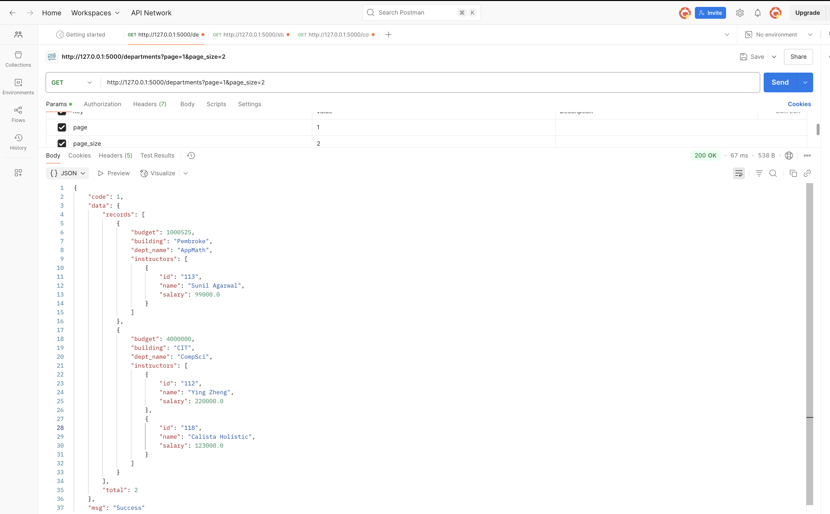
- Get Students
GET http://127.0.0.1:5000/students?page=1&page_size=2
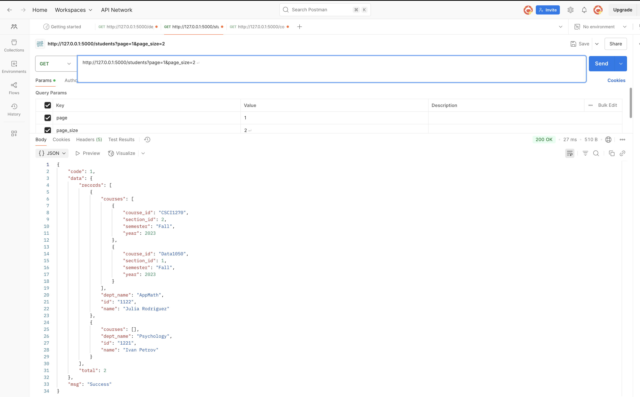
- Get Courses
GET http://127.0.0.1:5000/courses?page=1&page_size=2

